WheelScan — AI Recommendation Agent
ChatGPT Codex Hackathon 2026 | Track: Theme 8 ( AI for Societal Good )

1. Executive Summary
WheelScan is a mobile-first accessibility auditing app that lets anyone photograph a physical space like a ramp, doorway, elevator, parking lot, staircase, or road and instantly receive an accessibility score out of 100 with a detailed breakdown. For the ChatGPT Codex Hackathon 2026, we extended WheelScan with an AI Recommendation Agent, built primarily with OpenAI Codex, that turns every flagged accessibility issue into a clear, prioritized, standards-based action plan. The agent doesn't just repeat the score , it explains why each issue matters, what to do about it, how urgent it is, how much it will cost to fix, and how confident the system is in its own recommendation.
2. The Problem
Physical accessibility barriers are one of the most common and least documented obstacles faced by people with disabilities, elderly individuals, and anyone with temporary or permanent mobility limitations. In most cities and buildings:
- There is no easy, low-cost way to check whether a space is accessible before visiting it
- Manual accessibility audits require trained professionals, cost money, and happen rarely, usually only for new construction or after a complaint
- People with disabilities frequently discover a barrier only after arriving like a staircase with no ramp alternative, a doorway too narrow for a wheelchair, missing handrails, or no tactile warning at a stair edge
- Even when a building owner wants to fix accessibility issues, they often don't know what standard to follow, what the fix actually involves, or which issue to prioritize first
WheelScan already solved the first half of this problem, instant, photo-based scoring. But a raw score of "33/100 - Needs Improvement" tells a user that something is wrong without telling them what to do about it. That gap between diagnosis and action is what this hackathon build closes.

3. Target Users
User Group | Description
Individuals with disabilities or mobility limitations | checking a space before visiting
Building owners, shopkeepers, and facility managers | who want to improve accessibility but don't know where to start or what standards apply
Community volunteers and accessibility advocates | auditing public spaces and reporting issues to local authorities
NGOs and disability-rights organizations | aggregating accessibility data across a neighborhood or city

4. Objective
Build an AI agent that converts WheelScan's existing accessibility scores into specific, prioritized, and verifiable recommendations so that every audit ends not just with a number, but with a plan someone can actually act on.
5. Our Approach
We made one deliberate architectural decision at the very start : the existing scoring engine (scoring_service.dart) would not be touched. It already works, it's already tested, and rebuilding it wasn't the point of this hackathon. Instead, we built a new Recommendation Agent as a layer entirely on top of the existing scoring output.
For every criterion the scoring engine flags as WARNING or CRITICAL, the agent generates:
Field | What it does
Why it matters | Plain-language explanation of the real-world impact of this specific issue
Recommended fix | A specific, concrete action, not generic advice
Standard reference | The accessibility guideline or principle behind the recommendation
Priority rank | Ordered 1, 2, 3... by how much each fix matters for independent access
Impact label | e.g. High access impact / High safety impact
Effort label | e.g. High effort / Medium effort
Cost tag | e.g. Low cost — DIY / Medium — needs contractor / High — structural change
Confidence flag | High confidence vs. Verify on-site — the agent never overstates certainty from a single photo
How to verify | The exact physical check to confirm the fix actually worked
Agent self-check note | A visible line confirming the recommendation was reviewed for actionability before being shown e.g. "Draft generated from CRITICAL criterion and checked for actionability"

This last point , the visible self-check was a deliberate design choice. Rather than just showing a final answer, we wanted the reasoning process itself to be visible to the user, which is also what makes the "agentic" behavior demonstrable to evaluators rather than just implied.
Example - for a staircase audit :
Alternative Route — CRITICAL
Why it matters : A staircase without a nearby ramp or elevator creates a complete access barrier for wheelchair users and many people with mobility limitations.
Recommended fix : Provide a nearby ramp, platform lift, or elevator as the primary accessible route. Add clear signage at the staircase pointing users to that route.
Standard reference : Public access routes should include a step-free alternative wherever stairs are present.

6. System Architecture
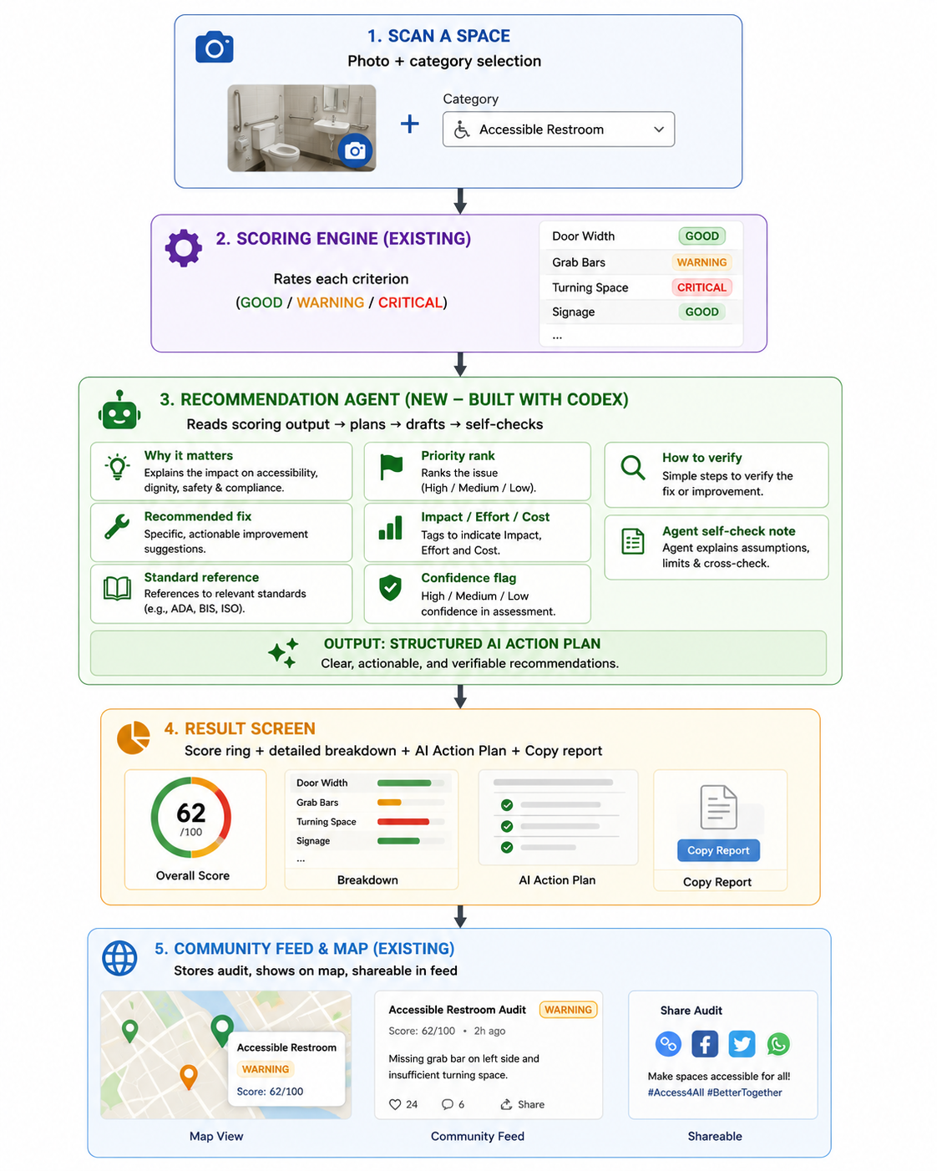

The scoring engine and the recommendation agent are fully decoupled , the agent only ever reads the scorer's output, never modifies it. This means we can honestly state to evaluators that the original scoring logic is completely untouched, and the new agentic layer is additive.

7. Tech Stack

Technology | Purpose
Flutter 3.38 | Cross-platform UI framework
Dart 3.10 | Programming language
OpenAI Codex | Agentic build partner, planning, code generation, and self-review of the Recommendation Agent
image_picker | Camera and gallery access
CustomPainter | Score ring animation, map rendering, and the agent-reasoning-trace animation
AnimationController | Splash, score, card, and reasoning-trace animations
Material Design 3 | UI components and theming

8. How Codex Was Used (Agentic Process)
This project was built primarily with OpenAI Codex, used as a genuine agentic collaborator rather than a single-shot code generator. The build happened across multiple iterative rounds:
- Round 1 — Core feature build
Codex was given a full project brief describing the existing app, the exact gap (score without guidance), and a precise specification of what to build: a new recommendation module that reads the scoring engine's output, generates specific fixes, ranks them, and self-reviews before finalizing. Codex planned the data structure changes, generated the recommendation logic, and connected it to the existing UI without modifying the scoring engine.

- Round 2 — Making the agentic behavior visible
After reviewing the first working version, we asked Codex to add : a visible reasoning trace shown before the final plan appears (Reading flagged criteria → Drafting → Self-checking → Ranking), separate confidence and cost fields (so the UI could distinguish "how certain are we" from "how hard/costly is this fix"), and a Copy Report button. Codex implemented all three directly, then ran its own source-level checks for constructor and syntax issues before we tested again.
- Self-review discipline carried over from Codex's own workflow
We treated Codex's own recommended review practices as our own quality bar throughout : failing-test-first logic where possible, read-only review passes before committing changes, and demanding concrete evidence (an actual standard reference, a specific fix, not just "this looks fixed") before accepting any agent-generated recommendation as final. This is directly reflected in the product itself, the same self-check discipline we used to review Codex's output is what the Recommendation Agent applies to its own generated advice before showing it to the end user.

9. Real-World Impact
- Turns a static accessibility score into an actionable plan any individual or building owner can use immediately
- Removes the need for a paid consultant just to understand what to do about a low score
- The confidence flag (High confidence vs. Verify on-site) makes the tool honest about the limits of photo-based assessment, rather than overstating certainty
- Cost and effort tags help prioritize fixes realistically , a small business owner can tell at a glance which fix is a quick DIY job versus a major structural project
- Directly supports independent, dignified access to public and private spaces for people with disabilities, elderly individuals, and anyone with temporary mobility limitations

10. Future Scope
- Real computer vision (e.g. a trained MobileNetV2/TFLite model) for actual image-based issue detection, the current agent works from the existing rule-based scoring output, not live visual analysis, and this is the natural next step
- Firebase backend for authentication, Firestore storage, and cloud sync
- Google Maps SDK integration for real GPS-based location mapping
- PDF export of the full audit and action plan
- Voice input and multi-language support (Hindi, Spanish, French, Arabic)
- Aggregate insight across community audits ; e.g. surfacing the most common critical issue in a given area to flag to local authorities

11. Links
- Live app : https://wheelscan-app-d6180.web.app
- GitHub repository : https://github.com/Alvira-Parveen/WheelScan
- Demo video : https://drive.google.com/file/d/1XXF7-P0ZhTM1o4C_DMGoJ69CPkkVZVJY/view?usp=drive_link

12. Conclusion
WheelScan's AI Recommendation Agent demonstrates genuine agentic behavior, planning, generating, and self-reviewing real recommendations built on Codex, on top of an existing, unmodified accessibility scoring system. It closes a real gap between diagnosis and action for a problem that affects millions of people navigating physical spaces every day.

